

**Group number: 12**

**Students’ Names:**

Ahmed Ahmed Alwasefy

Ibrahim Mostafa Elshenhapy

Mohamed Salah Gabr

**Date:**

**2023/05/27**

**Assignment 1**

**Attention:**

|  |
| --- |
| 1. Only one of the group members should submit the solution. 2. You have to submit the solution using this template. 3. Your code and this report file must be attached in Brightspace. 4. In this file, first talk about modifications you did in code, then results (texts, figures, …). Finally list the name of the files you attached in Brightspace |



# Task 1

## 1- Modifications in code

Please provide images of modifications in code. Highlight the parts you have changed.

## 1-2- Results

Please provide your output (figures, texts, …)

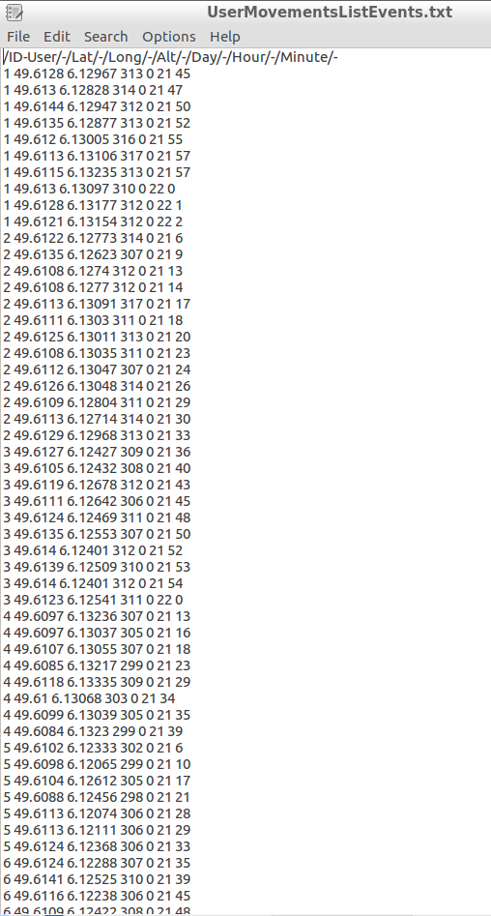

## List of files

Please attach this file and modified code file in Brightspace. Also, mention the name of the files you have attached in Brightspace.

* Assignment 1-answer template.docx
* Crowdsensim2.py
* Setup.txt
* UserMovementListEvent_0.txt



# Task 2

## 1- Modifications in code

Please provide images of modifications in code. Highlight the parts you have changed.

## Results

Please provide your output (figures, texts, …)

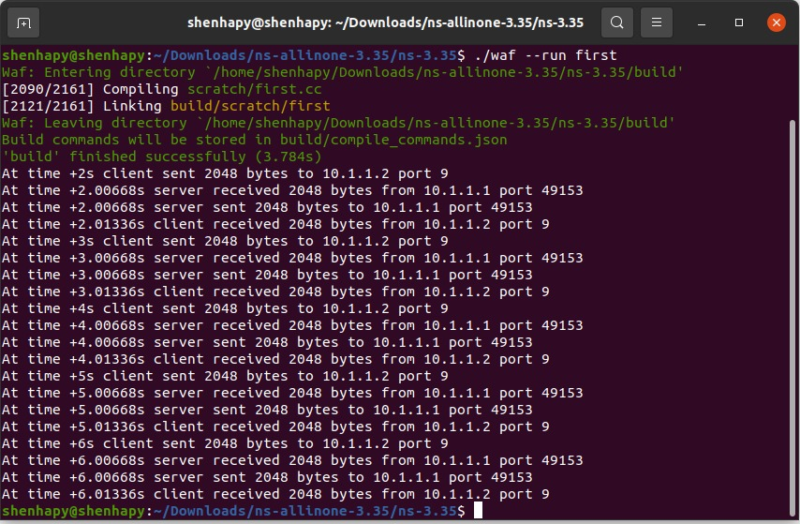

## List of files

Please attach this file and modified code file in Brightspace. Also, mention the name of the files you have attached in Brightspace.

* first.cc
* logfile-0-0.pcap
* logfile-1-0.pcap
* Assignment 1-answer template.docx